Volunteer Role Description 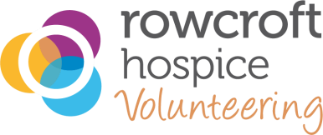

Volunteer Role House Clearance Service Receptionist
Managed by Volunteer Manager
Where you will be based Rowcroft Teignmouth Road Warehouse, Torquay

Role summary

We aim to make every day the best day possible for our patients and their families in South Devon. This volunteer role is essential, as you’ll play a key part in supporting Rowcroft’s newest commercial House Clearance venture. By taking calls, recording callers’ details, and logging them on our EPOS booking system, you’ll help grow the House Clearance service and generate vital funds for the Hospice.

What you may be doing
• Taking calls from potential house clearances/furniture collection clients
• Answering any questions they may have ascertaining to the service
• Making calls to confirm details and book in time slots
• Entering the data onto our EPOS booking system
• Appraising the house clearance manager of the bookings
• Full training and support, with occasional attendance at Team Training sessions

This role will suit you if you
• You feel confident speaking to people over the phone
• You’re friendly, reliable, and enjoy connecting with people
• You enjoy being part of a team and supporting others
• You’re passionate about Rowcroft’s mission and community spirit
• You’re organised, calm under pressure, and able to follow guidance

This role could bring you
• A chance to meet new people and work as part of a team
• The opportunity to support a well-loved local charity in a meaningful way
• Confidence and experience in professional telephony
• New friendships, fun memories, and the joy of helping others succeed
• The satisfaction of knowing you’ve helped make a real difference for local families facing the hardest times

All Rowcroft volunteers will be asked to
- Attend a Welcome Day to learn more about the hospice and where your role fits.
- Respect and uphold Rowcroft’s values of: Honesty & Integrity; Generosity of Spirit; Respect; and being a Team Player.
- Act according to our policies, practices and procedures as shared during your induction and any updates.
- Complete any training and update sessions required for your role.

RD V11-2023

